## Raspberry Pi Computer Vision Comparison Images

### Haar Classifier

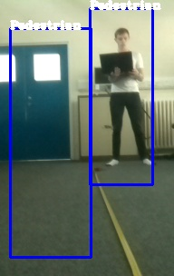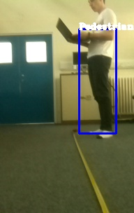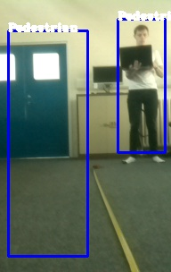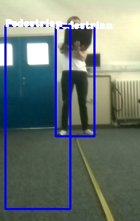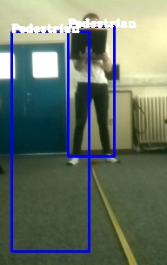

Comparison (Haar) 4

Comparison (Haar) 5

Comparison (Haar) 1

Comparison (Haar) 2

Comparison (Haar) 1

### HOG Descriptor

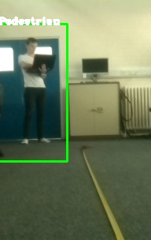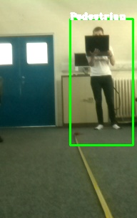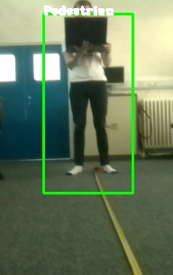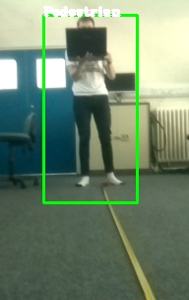

Comparison (HOG) 5

Comparison (HOG) 4

Comparison (HOG) 1

Comparison (HOG) 2

Comparison (HOG) 1